Ongoing log of questions and clarifications during MSFD reporting
Helpdesk log, version 24-10-2014
helpdeskWISEreporting@atkinsglobal.com

The following is a list of issues and clarifications that have arisen during the MSFD reporting period ending October 15. This list covers comments/issues identified in the schemas, database, supporting documents and tools and the appropriate action/response.
Contents
1. Technical queries 1
2. Guidance documents 6

Technical queries
No. | Reporter | Area | Issue | Response
 | UK | Error in name | An error has been spotted by UK for MSFD art 11 reporting (web forms). Under General Description-Regions the term list needs correction as follows:  NE Atlantic Ocean: Greater North Sea  NE Atlantic Ocean: Celtic Seas  NE Atlantic Ocean: Bay of Biscay and Iberian Coast  NE Atlantic Ocean: Macaronesia  Can you please adjust. | Fixed
 | UK | Country specific lists | It seems under question 6a Links to Art. 10 targets, would mean we have to answer everything from Article 10 reporting again. Surely there is an easy fix from your site to link this to our previous reporting, otherwise it would duplicate our efforts from previous reporting rounds? | I know it would be nice to have an automated pre-filling of the list of relevant targets and indicators. But to extend the web forms with this functionality is not that straight forward and is costly and that’s why we together with the Commission decided not to do new development back then. The current set-up for Q1c in the web forms is in line with the adopted schema and that’s the main priority when providing the tools (screen grab nr.2).  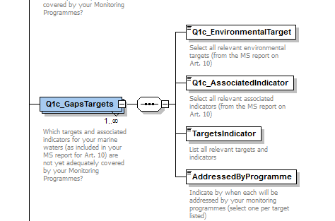
 | UK | Web form Q7e | Just another issue that I found.  In the webform under the programme section there are 5 questions under 7e, but if you look at the output of the webform you have 6 questions that are visible, of which one is of course not answered as it should not be there. This could cause trouble in the validation process as people may think a box was not ticked.  Could you therefore remove the question Established methods for assessment: Yes or no? As it is NOT a question in this section, hence no answer with it. | Question removed
 | NL | Q10b | I found another one in the XML schema validation:  Question 10b is always mandatory, however, the question reads:  “10b: Description Data Aggregation : If 'other' is selected, describe the scale. If the data cannot be aggregated (beyond the national scale), give reasons?”  If I did not select ‘other’ or ‘unknown’ in question 10a, I believe this question should not be mandatory. | Fixed
 | NL | Q1a | I have also detected a small error in the webform (or in the making of the xml from the webform). For question 1 a, criterion 4.2: I have ticked in the webform the box ‘2014’, however the xml shows ‘not relevant’. | Fixed
 | NL | Sub programmes | We have finalised filling in some of the sub-programmes reporting sheet and today I ran the XML Schema validation. For all subprogramme xmls it gives the same errors, see the screenshot below. I have attached one subprogramme-xml to this email.  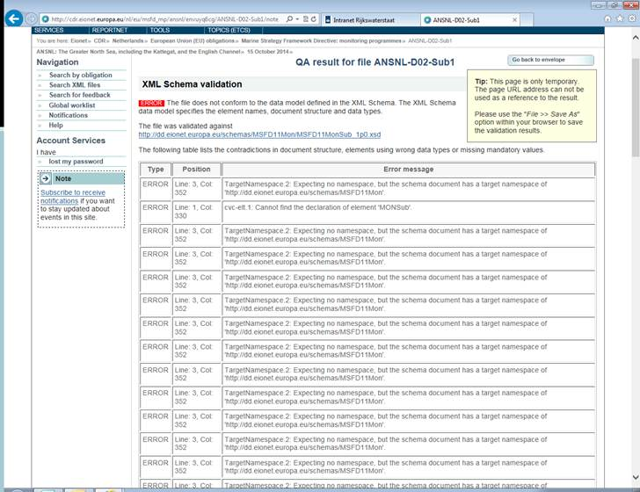 | We detected some wrong namespaces in the schema file. This has now been corrected.
 | NL | Q1d | Under 1d habitats I get a limited list of habitats, which are not those reported under art 8 for the Netherlands (I get to see for example LitRock, LitSed, ShallRock, ShallSed, ShelfRock, ShelfSed, BathAbys, IceHabitat, while NL reported having ShallSand, ShelfCoarseSed, ShelfMxdSed and ShelfSand) – maybe the lists are mixed up? | I hereby return to you on the issue of the list of habitats under question 1d that was reported incomplete in your mail below. As promised by Morten we have discussed this with the Commission.  The list for Q1d has aggregated some of the habitat types in the list for Q5c to simplify the reporting under Q1 because, at the overall Art 11 level, the report need not have the level of detail that is more appropriate at Programme level.  Hence we will not introduce any changes to the schemas at this stage of the reporting.
 | EE | How to add more than one sub-monitoring programmes | Thank you for your answer. Maybe you could help me with one more. In the sub-programme level in web-forms, how can I make more sub-programmes ? I can't find the right place to add subprogrammes. Can you help me with that, beacuse I haven't recieved an aswer from the helpdesk. | You'll need to add a new file in the system (see screen grab below). Unfortunately the current set-up only allows you to click and edit one XML instance. If you need to add more sub-programmes click add file and browse to your XML instance. If need be you can find templates for XML instances at the resource page where there's also a mini-guide how to ad and modify the files.  http://icm.eionet.europa.eu/schemas/dir200856ec/resources2014/XML_Templates.zip  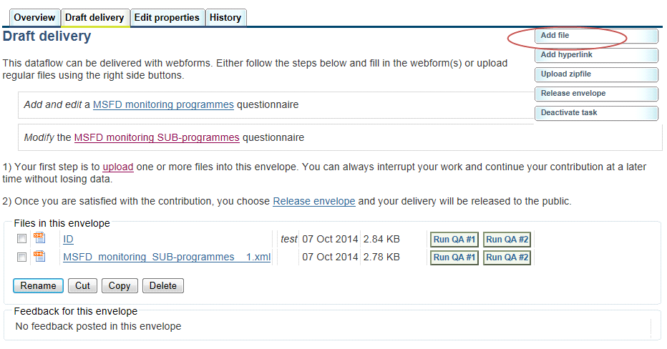
 | NL | Q6c | Question 6c: the answer(yes/no) that is given in the webform does not show in the webdisplay (it is in the xml, so no problem with reporting) | Fixed 21.10.2014
 | UK | Q7f | There is a transcription error between web form and style sheet. Selected values in the web form ( XML file) do not appear correctly in style sheet. | We are able to replicate the issue. Do any other MS experience this?
 | NL | Q7e | Sub question to 7e: Established methods for assessment: Yes or no? was taken out previously (see issue id 3). As it still appears in the reporting sheets it should be put in again | The sub question was removed from the web forms 16 September as a consequence of issue 3. It was then re-introduced in the web forms 21/10/2014. This mean that al MS’s who have reported after the 16 September have not had the change to report on this question.
 | UK | Q9b | There is a transcription error between web form and style sheet. ‘Temperature’ is ticked by default although its’ not chosen in the web form . | Fixed
 | UK | Q10b | There is a transcription error between web form and style sheet. The value ‘Other’ was chosen and the answer was specified is: Approximately every 20 years. This answer is not displayed in the style sheet | Fixed

Guidance documents
No. | Reporter | Area | Issue | Response
 | EE | Content and country specific lists for targets | 1) Question 9a - Here I have to list specific elements that are monitored.  When monitoring let's say zooplankton, do I have to list all of the species that have been monitored in the past, I mean one can never know what species they're going to find (regarding non-indigenous species)? Or is it suitable, if I just put 'zooplankton' ?  2) Question 5c - Here I can find habitat, pressure, species and phys-chemical features options and all of the 4 categories have a * infront of them, which (if I understand correctly) means, that I have to fill them out. But what happens if a subprogramme doesn't include all of the 4 above mentioned groups ? Do I just leave something empty and explain in the programme level (gaps)?  3) Question 6a - Here we have two sub-questions:  1 - Select relevant environmental targets - list from 1 to 29. Are these numbers in accordance with the numbers in the Commission assessment of reporting on art. 8, 9 and 10? I ask this, because in our national report, the targets are not numbered.  2 - Select relevant associated indicator targets - list from  1 to 29. Answering this question, do I have to choose the number/target which is in accordance with the programme and has indicators with the specific target(number) ?  4) And a broader question about targets - There are many questions that require yes/no answers or free text answers to issues regarding the assessment of progress towards achievement of relevant targets. My question is, how can I answer these kinds of questions, if Estonias targets are mostly non-quantitative, not time-bound and without specific tresholds etc ? Should I just leave them (Q6b, Q6d) empty and explain in the gaps in 6f ? | From the Commission:  - Zooplankton is suitable level of detail here.  - Just provide the relevant elements from the lists of options.  - 1.The targets listed are from YOUR Art 10 report (i.e. specific to Estonia) - the numbers 1-29 should therefore relate to what was reported in 2012. If the numbers do not make any sense to you (as you indicate) please contact the helpdesk and ask where these came from. 2. Presume this is a list of your art 10 indicators (one per target?). Again, please clarify with the help desk if these do not relate to what you reported in 2012.  - DC - I would use your best judgement as to whether you can answer the specific questions; you can use the 6f text field to provide a suitable explanation (e.g. if it is not possible to answer previous questions).
 | SR | Content | We would kindly ask for your assistance concerning reporting under Article 11 of MSFD (Monitoring Programme), General Description, Questions: 1a and 1b (and similar ones as 1c, 1ds, but also questions on Monitoring Programmes 5d and 5g).  Could you, please, explain do the questions 1a and 1b (1c, 1ds, 5d and 5g) address the Monitoring Programme as a document (has it been adequately planned) or the monitoring (protocol) implementation itself? If we consider our Monitoring Programme (fully) adequately planned (but it's implementation hasn't started yet):  - Do we answer Q1a: YES?  - What answer should we provide for the Q 1b (1c, 1ds, 5d and 5g): BY 2014 or NOT RELEVANT?  Thank you in advance for your help!

